FA17 Final Project ECE36200

Crops Plantation System

**Objective:**

Farmers are looking for method to automate crops plantation process to increase the efficiency of labor force and the quality of crops. Write an assembly program to simulate a **Crops Plantation System**. This system has the functionalities that include harvester, sprinkler irrigation and pest detection. Usability and functionality are high priorities for the farmers who are using this system, so it must have a menu that allows user to have full control on the setting of the system. The overall objective is to create a program that replicates the interface of a crops plantation system that is user friendly and free of glitches.

**Peripheral Simulations:**

1. *Stepper Motor:* The stepper motor is meant to replicate 3 agriculture machineries. The machineries are chisel plow, seeds drill and combine harvester. Chisel plow will plow the field by spinning in anti-clockwise direction with a relatively fast speed; seed drill will plant seeds to the field by spinning in clockwise direction with a relatively slow speed; combine harvester will harvest the crops by spinning in anti-clockwise direction with a relatively slow speed.
2. *DC Motor:* The DC motor is meant to replicate the sprinkler system and fertilizer spreader. The sprinkler system should spin at medium speed (flow rate of 50% duty cycle) to irrigate water to the crops. The fertilizer spreader should spin at slow speed (flow rate of 10% duty cycle) to spread the fertilizer across the field. The flow rate of sprinkler system and fertilizer spreader can be adjusted according to the field condition provided from switches.
3. *Keypad:* The keypad is the primary way that the user provides input to the crops plantation system. User can use the keypad to make selections in different menu. Once user selects an option, it will guide the user to the next menu. When one of the switches is turned on to check the field condition, user can use keypad to increase the flow rate of fertilizer spreader to 50% duty cycle or to increase the flow rate of water sprinkler to 100% duty cycle. Overall, keypad should allow the user to maneuver the system smoothly.
4. *Potentiometer:* The potentiometer is meant to replicate the pesticides sprayer. When the pesticides sprayer is at its minimum value, no pesticides is being sprayed to the crops. When the pesticides sprayer is at its maximum value, pesticides is being sprayed to 100% of the crops.
5. *LCD:* The LCD screen is the user interface for this crops plantation system. Firstly, LCD will display a welcome screen. Then, LCD will guide the user to main menu of the system which contains 2 options. The selections are “New Farming Cycle”and “Fertilizing”. In “New Farming Cycle”, LCD should display the options for field plowing and seeds planting. If field plowing option is selected, the LCD screen should show ‘#’ ASCII character from left to right in row 1 of LCD screen then follows by row 2 of LCD screen to simulate the chisel plow machine plowing the field. (**refer to Appendix 1 & 2**) If seeds planting option is selected, the LCD screen should show ‘.’ ASCII character from left to right in row 1 follows by row 2 of LCD screen to simulate seed drill machine planting the seeds. User is not allowed to enter new farming cycle if there are plants on the field. User can only go into new farming cycle when the field is empty or when the previous crops has been harvested. In “Fertilizing”, LCD will display the options of spread fertilizer and sprinkle water. LCD screen should display the action that is being performed. When Push Button is pressed by user, LCD screen will display the status of the plant. If the status of the plant is “seeds”, the LCD screen should show ‘.’ ASCII character. If the status of the plant is “growing”, the LCD screen should show ‘*’ ASCII character. If the status of the plant is “matured”, the LCD screen should show ‘@’ ASCII character. If the status of the plant is “ready to be harvested”, LCD screen will display the instruction to guide user to harvest. When one of the switches is turned on to check the status of the field, LCD screen will guide user to make changes in the settings of the system to cope with the condition of the field. When IRQ button is pressed, LCD screen will display “PESTS DECTECTED! SPRAY PESTICIDES NOW!” for 3 seconds and then display instruction that would guide user to spray pesticides.
6. *Push Button:* Push button allow the user to check the stages of the crops. The crops have 4 stages: seeds, growing, matured and ready to be harvested. Each stage should be displayed accordingly to the real-time system. When the crops have reached “ready to be harvested” stage, user can press push button again to start harvesting the crops.
7. *Switches:* Switches let you check the condition of your field. When switch 1 and only switch 1 is on, it will check the soil fertility. If soil is not fertile, the flow rate of fertilizer spreader can be increased from 10% to 50% duty cycle. When switch 2 and only switch 2 is on, it will check the humidity. If the humidity is low, the flow rate of water sprinkler can be increased from 50% to 100% duty cycle.
8. *Speaker (Port T):* The speaker is meant to replicate the sound system of the crops plantation system. Sound system would play songs which last for a couple seconds, each song should be made up of a few different tones. When LCD screen shows the welcome menu to welcome user, speaker should produce a 5 seconds song. A different song should be produced by the speaker to imitate the movement of chisel plow machine and seed drill machine. Another song should be played when fertilizer is spreading and when water is sprinkling across the field. Lastly, the speaker should play a song that imitates the alarm if pests are detected in the field.
9. *LEDs (Port S):* The LEDs are meant to replicate the lighting system. The lighting system for this crops plantation system is to display a few patterns across LED when certain action is carried out. Different LED patterns should be displayed when LCD screen shows welcome menu, when the field is being plowed, when the seeds is being planted, when fertilizer is being spread and when water is being sprinkled. LED of lighting system should also blink when pests are detected in the field to give warning.
10. *IRQ:* When the IRQ button is being pressed, that acts as a trigger of pest detection. Then, pesticides sprayer will be activated to spray pesticides across the whole field to make sure that no damage is caused by the pest to the crops.
11. *Three extra items:* Your group should come up with three extra features, simple or complex. You are encouraged to be creative in your additional features.
12. RTI controls the timing of the simulation.

**Requirements:**

1. The overall layout of your system should be easy to understand and make sense. The user should be able to operate the system with little to no training or explanation. If you are unsure if the layout of your system makes sense, ask one of your TAs or fellow students to try to move through your system.

2. No delay loops are allowed (except keypad debouncing), you must utilize the Real Time Interrupt RTI.

**Note:**

You are encouraged to be creative and make this project your own. You can make reasonable assumptions in the development of this project, but keep in mind that the assumptions must make sense to the player/admin (and to the Lab TAs).

FOR YOUR PROJECT 10% OF THE GRADE WILL BE BASED ON EXTRAS THAT YOU WILL CREATE ON YOUR OWN. YOUR ARE ENCOURAGED TO BE CREATIVE THE MORE COMPLEX THE EXTRA THE MORE POINTS ARE EARNED.

ldaa rtiCtrl

staa temp

bset rtiCtrl,#%00100000

cli

ldd #pesterr

movw #3000,drawDL

jsr drawscreen

read:

jsr read_pot

clra

ldx #25

idiv

xgdx

cpd #10

beq max

addb #48

stab pestdisp+16

movb #'0',pestdisp+17

movb #'%',pestdisp+18

ldd #pestdisp

jsr display_string

MaxRT:

ldaa port_p

anda #%00100000

beq endpest

bra read

max:

movb #'M',pestdisp+16

movb #'A',pestdisp+17

movb #'X',pestdisp+18

ldd #pestdisp

jsr display_string

bra MaxRT

**Appendix A**

**ASCII Table**

You can refer to this ASCII table to look for the symbol that you need.

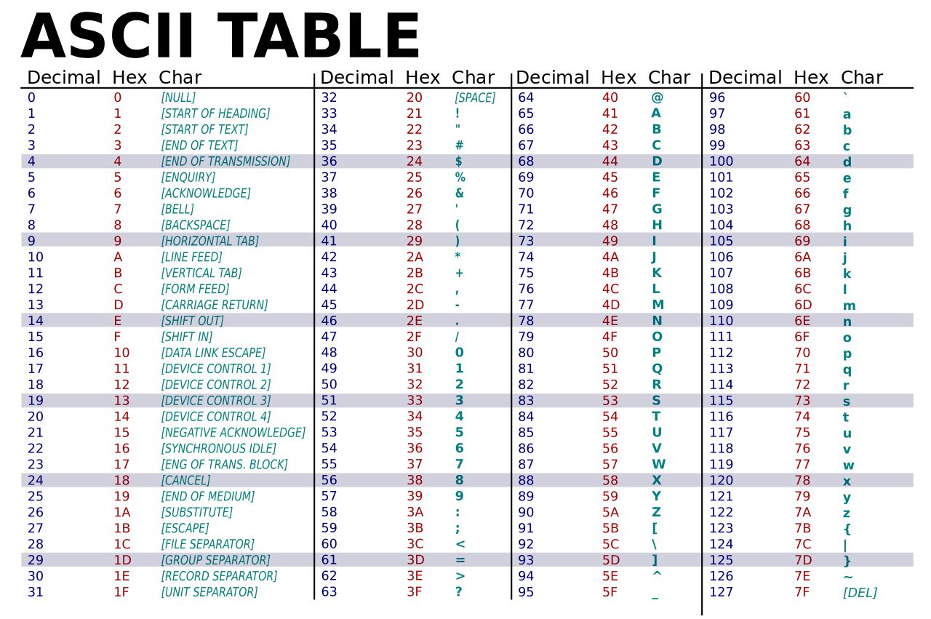

**Appendix B**

**Farming Process**

The LCD screen that we have in our microcontroller is 2x16, which means we have 2 rows that can fit 16 characters each. For actions like plowing the field, planting seeds and displaying of status of plants, the ‘s’ below should be replaced with their respective characters. There will be 7 plants following by 2 spaces following by another 7 plants in each row. For plowing the field action, its ASCII character “’#’ should be displayed 1 by 1 from left to right in row 1 follows by row 2. For planting seeds action, its ASCII character ‘.’ should replace ‘#’ 1 by 1 from left to right in row 1 follows by row 2. Then using RTI, ‘.’ will grow to be ‘*’, then ‘*’ will grow to be ‘@’, and ‘@’ will grow until it became ready to be harvested.

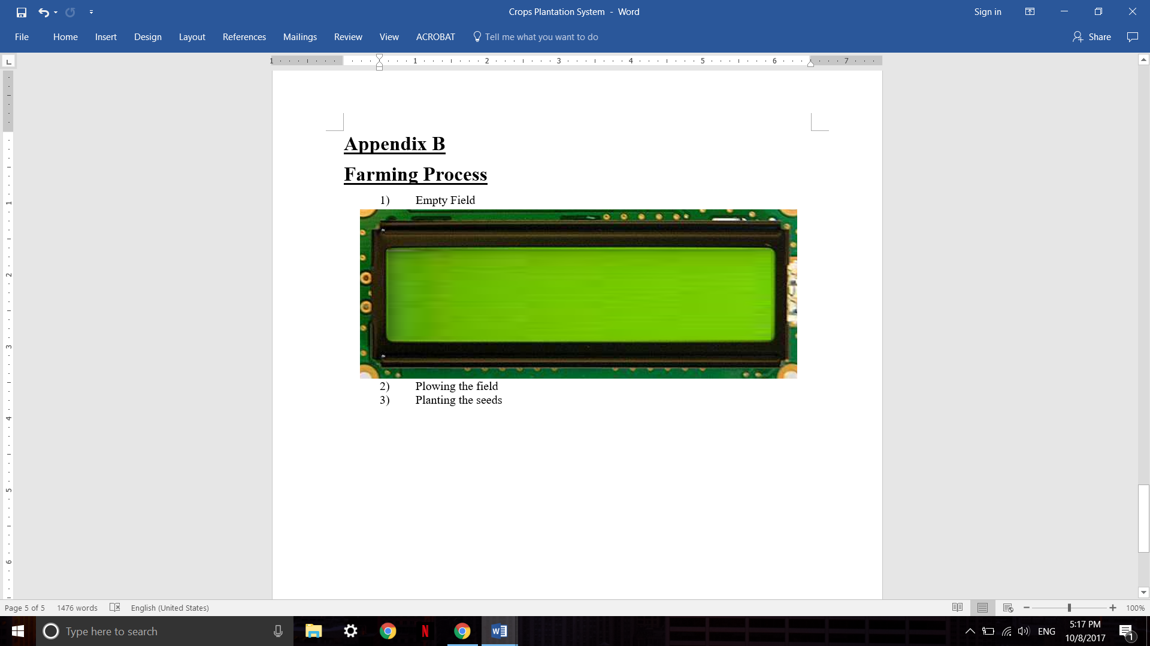Empty Field

Plowing the field/ Plating Seeds/Status of Plants  
  
  
  
 s s s s s s s s s s s s s s  
 s s s s s s s s s s s s s s